
Dear <Client Name>

We would like to invite you to our COVID-friendly open days on <date> at <location> to introduce you to Unitron. Over the next few weeks, we will be opening up a limited number of appointments to allow you to love the experience obligation-free.

All appointments on the day will be eligible for 5% discount on our standard retail pricing and will also receive a FREE TV connector.

We believe the world would be a better place if people felt really good about the entire hearing care experience. That’s why we focus on empowering people with smart hearing solutions.

Features include:
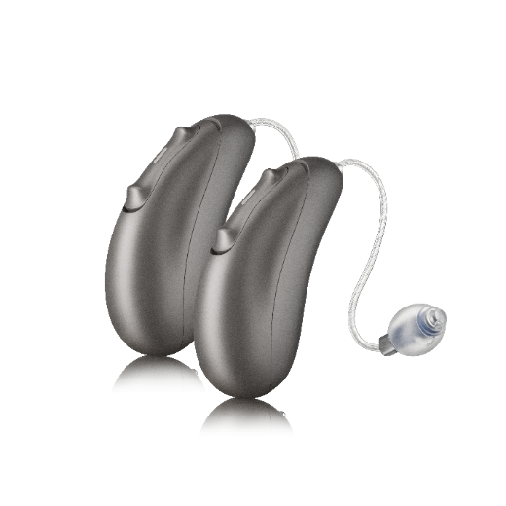
• Powered by Sonova’s technology with a focus on quality of sound and quality of life
• Personalised digital solutions
• Universal connectivity to iOS®, Android™ and just about any Bluetooth device, including smartphones, smart TVs and more
• Tap Control* for easy access to Bluetooth functions
• Powerful rechargeable battery*

I look forward to seeing you in the clinic to try Unitron’s latest products.
Moxi Blu R

Call us today to schedule your open day appointment.

* These features are only available in our latest platforms.

Sincerely,

<Clinician details>

Clinic name
Address
Website

